深度學習HW3 吳玫萱

RE6091054

Python (version 2.7.17) on a Linux server (V100 CUDA Version: 11.0).

GitHub link：

<https://drive.google.com/file/d/1uXtA69DnxYvxUamkkupL0sbqij2kmwIU/view?usp=sharing>

參考code：

<https://github.com/toxtli/lenet-5-mnist-from-scratch-numpy/blob/master/app.py>

<https://github.com/jieyr3Rui/lenet5-mnist-numpy/blob/master/lenet-5.py>

LeNet5_improved accuracy：

|  |  |  |  |
| --- | --- | --- | --- |
|  | train | vaild | test |
| Perceptron_1 | 0.0 | 0.02 | 0.02 |
| Perceptron_5 | 0.0 | 0.1 | 0.1 |

Train loss

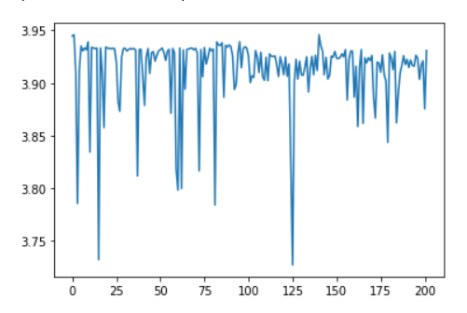

Train and validation accuracy plot show

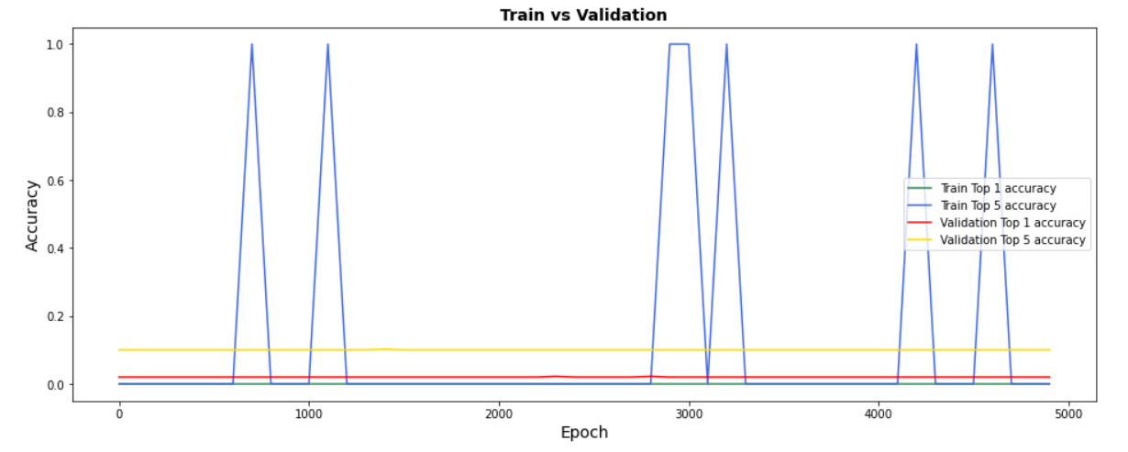

How to used my code

LeNet_cupy.ipynb is improved LeNet5 model.

LeNet(sigmoid)_cupy.ipynb is LeNet5 model.